Advanced Programming (Java)
Polymorphism, Abstract Classes & interfaces
Week 6 – Daily Work and Practice Material
Problem 6.1 and & 6.2 to be done on Tuesday
Problem 6.3 and & 6.5 on Wednesday
6.4 is for practice

6.1 Ex: Abstract Superclass Shape and Its Concrete Subclasses
Rewrite the superclass Shape and its subclasses Circle, Rectangle and Square, as shown in the class diagram.
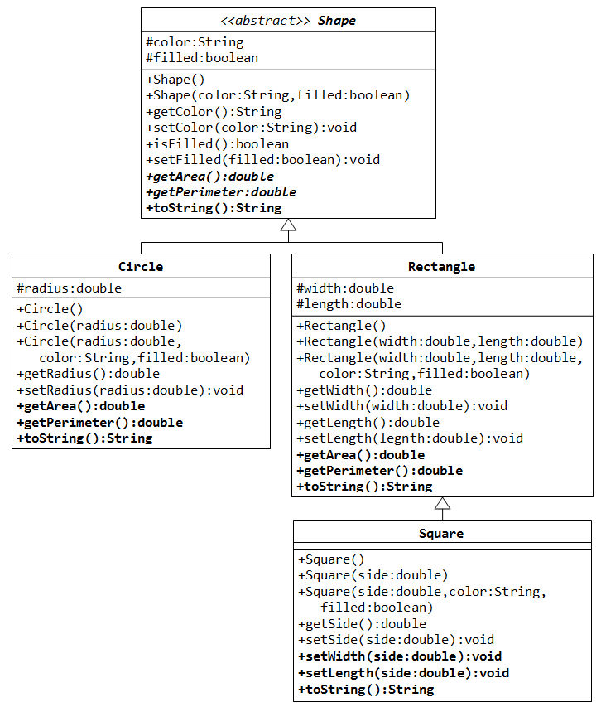

In this exercise, Shape shall be defined as an abstract class, which contains:
- Two protected instances variables color(String) and filled(boolean). The protected variables can be accessed by its subclasses and classes in the same package. They are denoted with a '#' sign in the class diagram.
- Getter and setter for all the instance variables, and toString().
- Two abstract methods getArea() and getPerimeter() (shown in italics in the class diagram).
Subclasses Circle and Rectangle shall override the abstract methods getArea() and getPerimeter() and provide the proper implementation. They also override the toString().
Write a test class to test these statements involving polymorphism and explain the outputs. Some statements may trigger compilation errors. Explain the errors, if any.
Shape s1 = new Circle(5.5, "RED", false); // Upcast Circle to Shape
System.out.println(s1); // which version?
System.out.println(s1.getArea()); // which version?
System.out.println(s1.getPerimeter()); // which version?
System.out.println(s1.getColor());
System.out.println(s1.isFilled());
System.out.println(s1.getRadius());

Circle c1 = (Circle)s1; // Downcast back to Circle
System.out.println(c1);
System.out.println(c1.getArea());
System.out.println(c1.getPerimeter());
System.out.println(c1.getColor());
System.out.println(c1.isFilled());
System.out.println(c1.getRadius());

Shape s2 = new Shape();

Shape s3 = new Rectangle(1.0, 2.0, "RED", false); // Upcast
System.out.println(s3);
System.out.println(s3.getArea());
System.out.println(s3.getPerimeter());
System.out.println(s3.getColor());
System.out.println(s3.getLength());

Rectangle r1 = (Rectangle)s3; // downcast
System.out.println(r1);
System.out.println(r1.getArea());
System.out.println(r1.getColor());
System.out.println(r1.getLength());

Shape s4 = new Square(6.6); // Upcast
System.out.println(s4);
System.out.println(s4.getArea());
System.out.println(s4.getColor());
System.out.println(s4.getSide());

// Take note that we downcast Shape s4 to Rectangle,
// which is a superclass of Square, instead of Square
Rectangle r2 = (Rectangle)s4;
System.out.println(r2);
System.out.println(r2.getArea());
System.out.println(r2.getColor());
System.out.println(r2.getSide());
System.out.println(r2.getLength());

// Downcast Rectangle r2 to Square
Square sq1 = (Square)r2;
System.out.println(sq1);
System.out.println(sq1.getArea());
System.out.println(sq1.getColor());
System.out.println(sq1.getSide());
System.out.println(sq1.getLength());
What is the usage of the abstract method and abstract class?

6.2 Ex: Polymorphism
Examine the following codes and draw the class diagram.
abstract public class Animal {
abstract public void greeting();
}
public class Cat extends Animal {
@Override
public void greeting() {
System.out.println("Meow!");
}
}
public class Dog extends Animal {
@Override
public void greeting() {
System.out.println("Woof!");
}

public void greeting(Dog another) {
System.out.println("Woooooooooof!");
}
}
public class BigDog extends Dog {
@Override
public void greeting() {
System.out.println("Woow!");
}

@Override
public void greeting(Dog another) {
System.out.println("Woooooowwwww!");
}
}
Explain the outputs (or error) for the following test program.
public class TestAnimal {
public static void main(String[] args) {
// Using the subclasses
Cat cat1 = new Cat();
cat1.greeting();
Dog dog1 = new Dog();
dog1.greeting();
BigDog bigDog1 = new BigDog();
bigDog1.greeting();

// Using Polymorphism
Animal animal1 = new Cat();
animal1.greeting();
Animal animal2 = new Dog();
animal2.greeting();
Animal animal3 = new BigDog();
animal3.greeting();
Animal animal4 = new Animal();

// Downcast
Dog dog2 = (Dog)animal2;
BigDog bigDog2 = (BigDog)animal3;
Dog dog3 = (Dog)animal3;
Cat cat2 = (Cat)animal2;
dog2.greeting(dog3);
dog3.greeting(dog2);
dog2.greeting(bigDog2);
bigDog2.greeting(dog2);
bigDog2.greeting(bigDog1);
}
}

6.3 Ex: Interface Movable and its implementations MovablePoint and MovableCircle
Suppose that we have a set of objects with some common behaviors: they could move up, down, left or right. The exact behaviors (such as how to move and how far to move) depend on the objects themselves. One common way to model these common behaviors is to define an interface called Movable, with abstract methods moveUp(), moveDown(), moveLeft() and moveRight(). The classes that implement the Movable interface will provide actual implementation to these abstract methods.
Let's write two concrete classes - MovablePoint and MovableCircle - that implement the Movable interface.
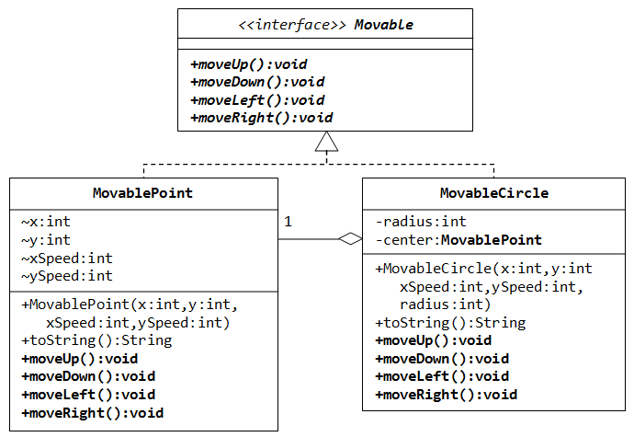
The code for the interface Movable is straight forward.
public interface Movable { // saved as "Movable.java"
public void moveUp();
public void moveDown();
public voide moveLeft();
public void moveRight();
}
For the MovablePoint class, declare the instance variable x, y, xSpeed and ySpeed with package access as shown with '~' in the class diagram (i.e., classes in the same package can access these variables directly). For the MovableCircle class, use a MovablePoint to represent its center (which contains four variable x, y, xSpeed and ySpeed). In other words, the MovableCircle composes a MovablePoint, and its radius.
public class MovablePoint implements Movable { // saved as "MovablePoint.java"
// instance variables
int x, y, xSpeed, ySpeed; // package access

// Constructor
public MovablePoint(int x, int y, int xSpeed, int ySpeed) {
this.x = x;
......
}
......

// Implement abstract methods declared in the interface Movable
@Override
public void moveUp() {
y -= ySpeed; // y-axis pointing down for 2D graphics
}
......
}
public class MovableCircle implements Movable { // saved as "MovableCircle.java"
// instance variables
private MovablePoint center; // can use center.x, center.y directly
// because they are package accessible
private int radius;

// Constructor
public MovableCircle(int x, int y, int xSpeed, int ySpeed, int radius) {
// Call the MovablePoint's constructor to allocate the center instance.
center = new MovablePoint(x, y, xSpeed, ySpeed);
......
}
......

// Implement abstract methods declared in the interface Movable
@Override
public void moveUp() {
center.y -= center.ySpeed;
}
......
}
Write a test program and try out these statements:
Movable m1 = new MovablePoint(5, 6, 10, 15); // upcast
System.out.println(m1);
m1.moveLeft();
System.out.println(m1);

Movable m2 = new MovableCircle(1, 2, 3, 4, 20); // upcast
System.out.println(m2);
m2.moveRight();
System.out.println(m2);
Write a new class called MovableRectangle, which composes two MovablePoints (representing the top-left and bottom-right corners) and implementing the Movable Interface. Make sure that the two points has the same speed.
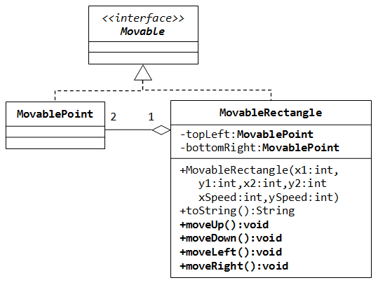

6.4 Ex: Interfaces GeometricObject and Resizable
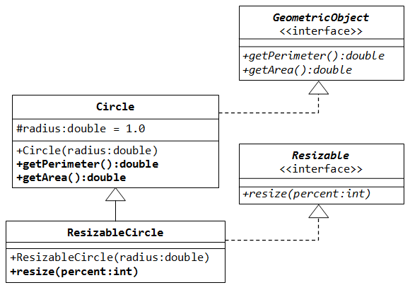
- Write the interface called GeometricObject, which declares two abstract methods: getParameter() and getArea(), as specified in the class diagram.
Hints:
public interface GeometricObject {
public double getPerimeter();
......
}
- Write the implementation class Circle, with a protected variable radius, which implements the interface GeometricObject.
Hints:
public class Circle implements GeometricObject {
// Private variable
......

// Constructor
......

// Implement methods defined in the interface GeometricObject
@Override
public double getPerimeter() { ...... }

......
}
- Write a test program called TestCircle to test the methods defined in Circle.
- The class ResizableCircle is defined as a subclass of the class Circle, which also implements an interface called Resizable, as shown in class diagram. The interface Resizable declares an abstract method resize(), which modifies the dimension (such as radius) by the given percentage. Write the interface Resizable and the class ResizableCircle.
Hints:
public interface Resizable {
public double resize(...);
}
public class ResizableCircle extends Circle implements Resizeable {

// Constructor
public ResizableCircle(double radius) {
super(...);
}

// Implement methods defined in the interface Resizable
@Override
public double resize(int percent) { ...... }
}
- Write a test program called TestResizableCircle to test the methods defined in ResizableCircle.

6.5 EX: Java Interfaces and UML
Implement the following class hierarchy on paper. You do not need to fill in the method bodies for the toss or bounce methods.
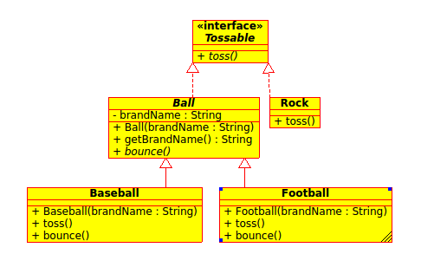
Answer the following questions:
How are abstract classes and interfaces the same?
How are abstract classes and interfaces different?
Why does it generally make more sense to override the equals method than to overload it?
Fill in the following table with one of three values.
✓ An object of the indicated type could be stored in a variable of the indicated type.
X An object of the indicated type could not be stored in a variable of the indicated type.
— It is not possible to instantiate an object of the indicated type.
 |  | Reference\Variable Type
 |  | Tossable | Ball | Rock | Baseball | Football
Object Type  (new keyword) | Tossable
Object Type  (new keyword) | Ball
Object Type  (new keyword) | Rock
Object Type  (new keyword) | Baseball
Object Type  (new keyword) | Football

Which of the following will compile (mark with a C)? Which of the following will execute successfully (mark with an E)?

1. Ball ball = new Football("spalding");

2. Ball ball = new Football("Spalding");
Baseball baseball = (Baseball)ball;

3. Object obj = new Baseball("spalding");

4. Object obj = new Baseball("spalding");
Tossable tossable = obj;

5. Tossable tossable = new Baseball("spalding");
Object obj = tossable;

